other topping ideas
- Strawberries
- Raspberries
- Blueberries
- Choc chips
- Sprinkles

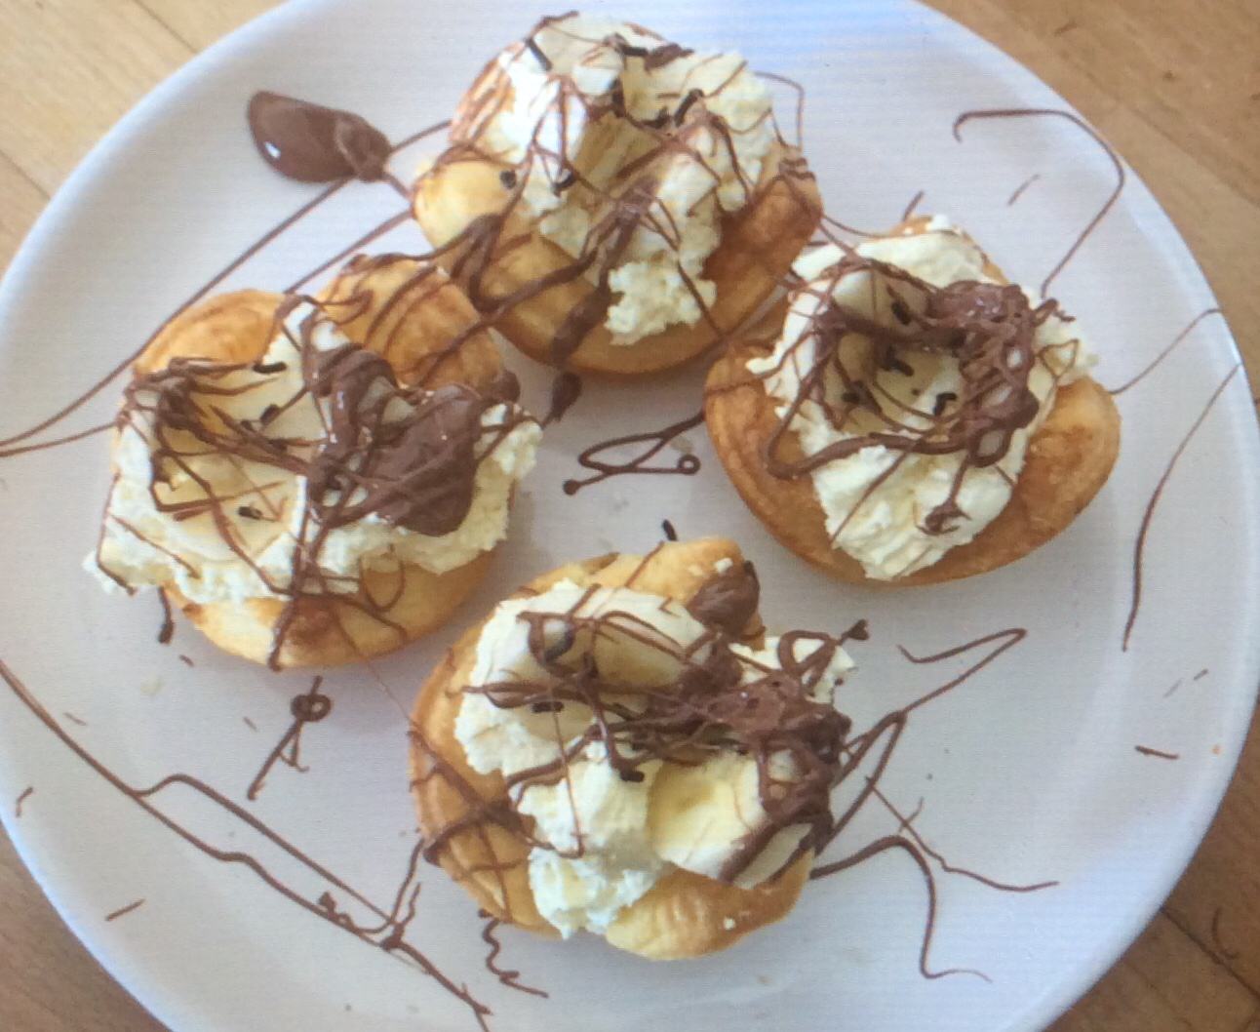

Fruit tarts
Makes up to 6

Ingredients
Shortcrust ready rolled pastry
200ml double cream
1 tblsp vanilla extract
1 banana
1 chocolate bar
Sprinkles
Knob of butter

Directions
- Preheat oven to 200c.
- Cut out your pastry shapes using a cutter and place in your muffin tray, make sure you have greased this first.
- Place in the oven and cook for around 8 minutes. Take out and leave to cool.
- In a bowl whisk together the cream and vanilla extract until thickened.
- Chop the banana and in a bowl melt the chocolate, for this you can use a bain-marie or pop it in the microwave.
- Scoop the cream in to each tart. Add the banana and a good pinch of sprinkles, then for the finishing touch drizzle the chocolate over the top to create some zigzags.
- Enjoy!

