other topping ideas
Strawberries
Raspberries
Blueberries
Golden syrup
Chocolate sauce
Maple syrup

French toast
Makes up to 4

Ingredients
4 slices of Bread
3 large eggs
Splash of full fat milk
½ tblsp of granulated sugar
2 tsp vanilla extract
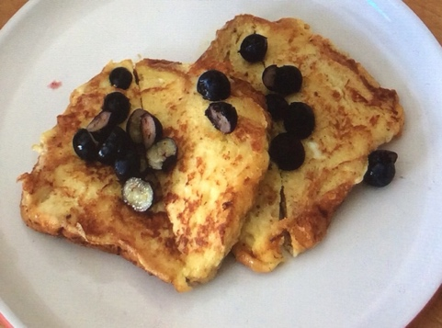
Knob of butter
Blueberries for topping

Directions
- In a bowl beat the eggs, milk, sugar and vanilla.
- Pour the mixture in to a shallow dish and place the bread slices in, leave to soak for about 2 minutes on each side.
- While your bread is absorbing the egg mix, you can ready your toppings. Use the bridge hold to chop your blueberries.
- Melt a knob of butter in a frying pan, then add a slice of bread. Fry on a medium heat until golden brown. Turn and fry the other side.
- Serve on a plate and add your toppings.
- Enjoy!

